Hey man,

This is an overview regarding the project.

Couleurs:

* Bleu
* Vert
* Orange

Domaine des telecommunications.

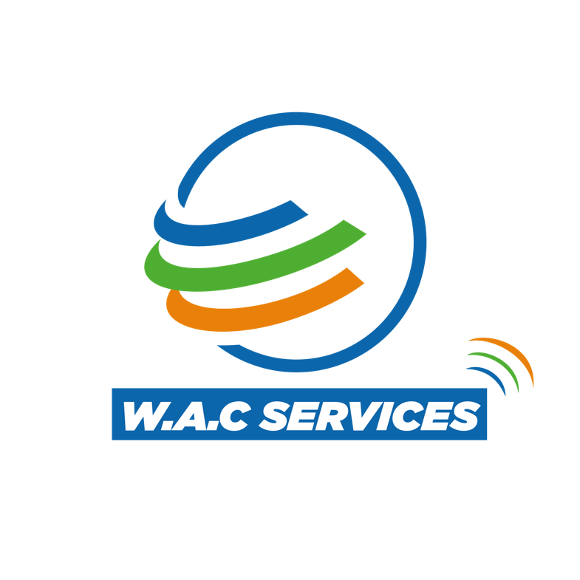

Site vitrine: <https://www.bigdropinc.com/>

Autres site a voir:

<https://www.konantech.net/>

<https://approve-it.net>

<https://bootstrap-menu.com/demos/fixed-onscroll.html>

https://bootstrap-menu.com/detail-fixed-onscroll.html

Pour le MENU on aura:

**Latest work- Services – About us – News**

**>> Services**

**EMC -RF - Energy Efficiency- support - Equipment and technologies**

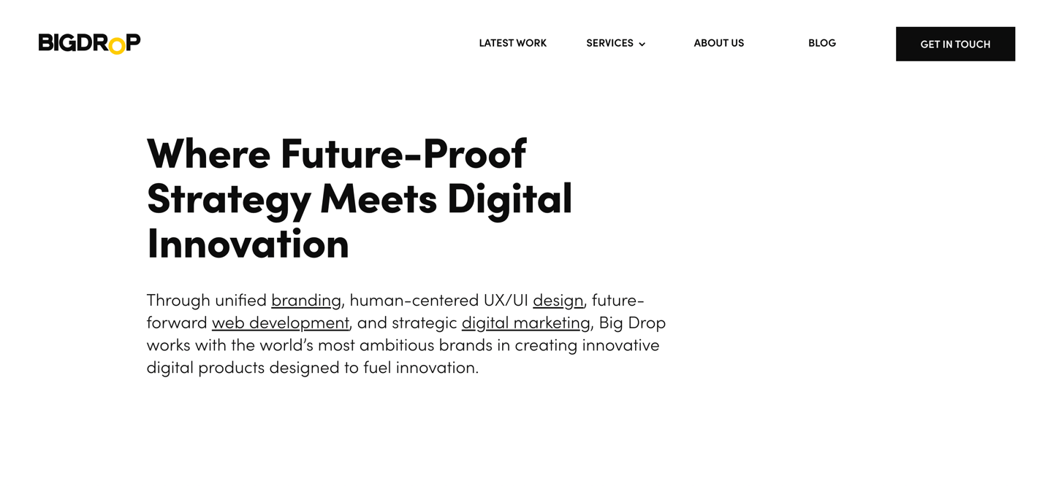

Text:

**Want to approve your equipment and access the global market?**

We are a qualified and dedicated team assisting you through the Approval process. We have been helping Manufacturers, Accreditation Bodies, Laboratories, and worldwide Vendors around the world to obtain regulatory approvals for their telecommunication devices in Africa, America, Middle East, and Asia.

Scroll down and see below

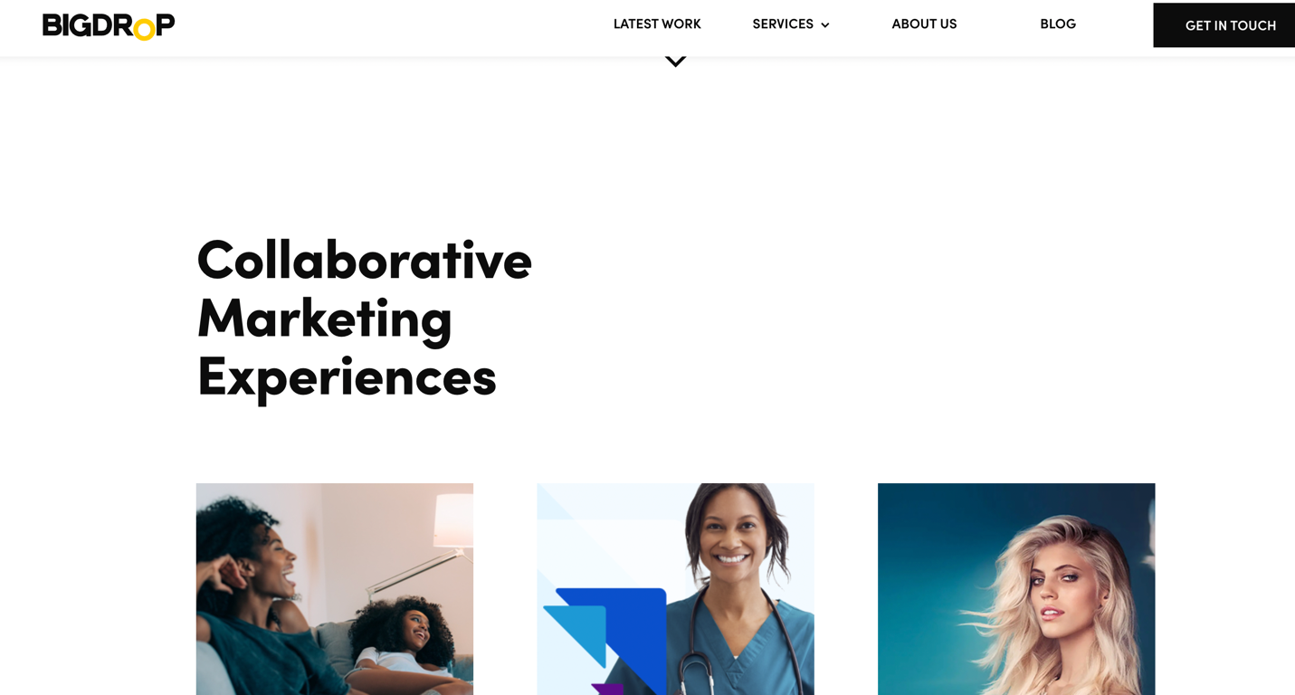

Text:

**Latest work**

Ps: En dessous des images on aura juste le nom des certificats et pays qui va nous ramener a la page de **News / updates.**

Mais en cliquant sur le certificate oin aura just le certificate en grand comme l’a fait un peu konan tech.

Scroll down and see below

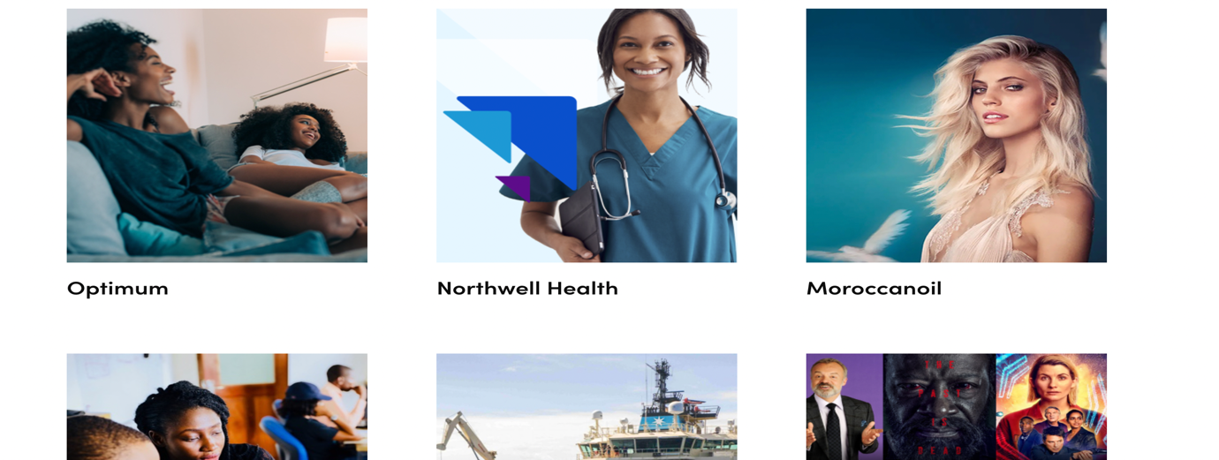

Scroll down and see below

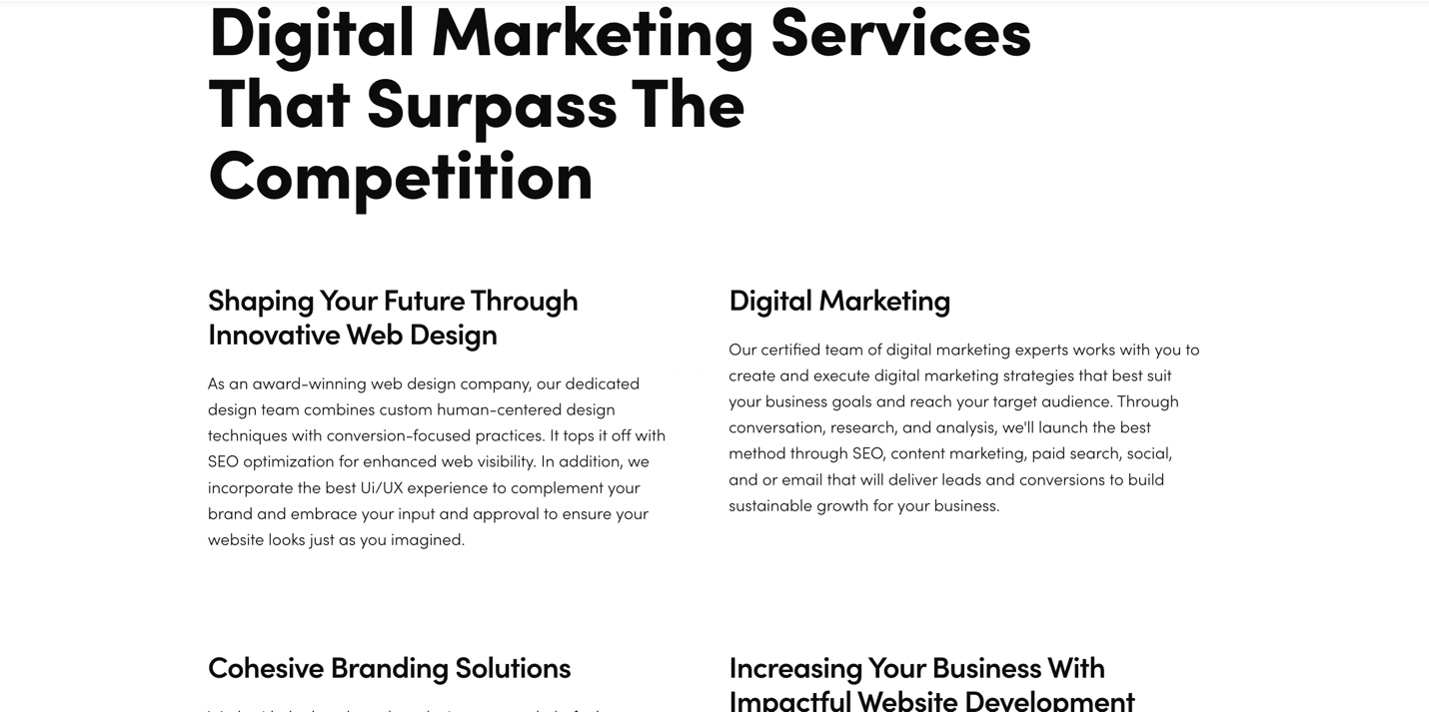

Text:

**The Type Approval Services that surpass the competition?**

|  |  |
| --- | --- |
| **Quick process Time**  We offer fastest service thanks to our large network of partners and local agents dedicated and client oriented. This team across the world are the best resource you need to achieve your goal. Having a long chain of partners may sometimes cause delay in the process. To avoid such delay, we ensure most of the time a direct communication within each Regulatory Authority.  View more | **Good Customers relationship**  Client satisfaction is one of our goals and we are committed to listen and understand to customers in order to give them what they want. We offer a proactive collaboration to client which is one of their favorite needs. For practicing honesty and managing expectations in a good way our clients are always satisfied and willing to give positive feedback.  View more |
| **Competitive costs**  Price is related to the services we are offering to our customers. You are never overpaying or underpaying with us. By working directly with regulatory authorities and local partners, we offer the best prices and services on the market.  With us, quality of service is guarantee and more, you make your company save money by not paying any extra-costs.  View more | **Flexibility in execution**  **Your Reliable information Support**  As your full-service Approval partner, you'll never have to worry about what is happened in the countries or Regulatory Authorities.  We ensure you get informed on time for any change which may impact the approval process.  View more |

View more

Ps: Vie more doit renvoyer a une mnouvelle page ou on a just le titre ‘**Quick process Time**’ te le texte sur la page en en dessous une image illustrative.

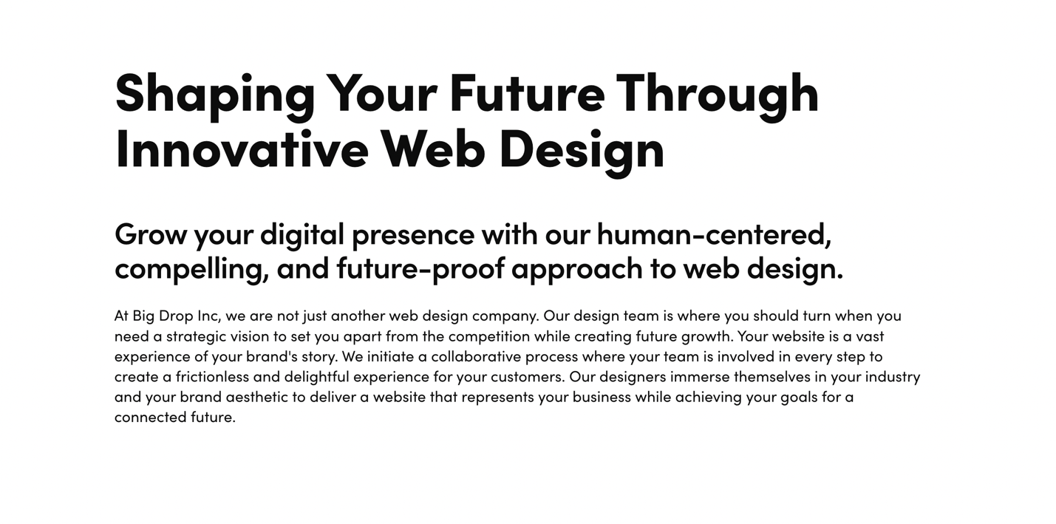

PS: Une image de ton choix pour chacun des 4 themes.

En dessous de cette page la on peut avoir juste la derniere page ou on voit clairement : **let’s talk.**

Enfin la derniere page du menu HOME.

(Le bas de page.)

Text:

Ps:

Want to approve your equipment and access the global market?

**Let’s Talk**

-----------------

|  |  |
| --- | --- |
| Abidjan  Akeikoi- Djibi  Abidjan, Cote d’Ivoire  (225) 0704294197 | World approval certification services  Wac-services is your preferred partner to approve your equipment and access the global market.  Copyright 2022. Wac-services All rights reserved.  Terms and conditions  Privacy Policy. |

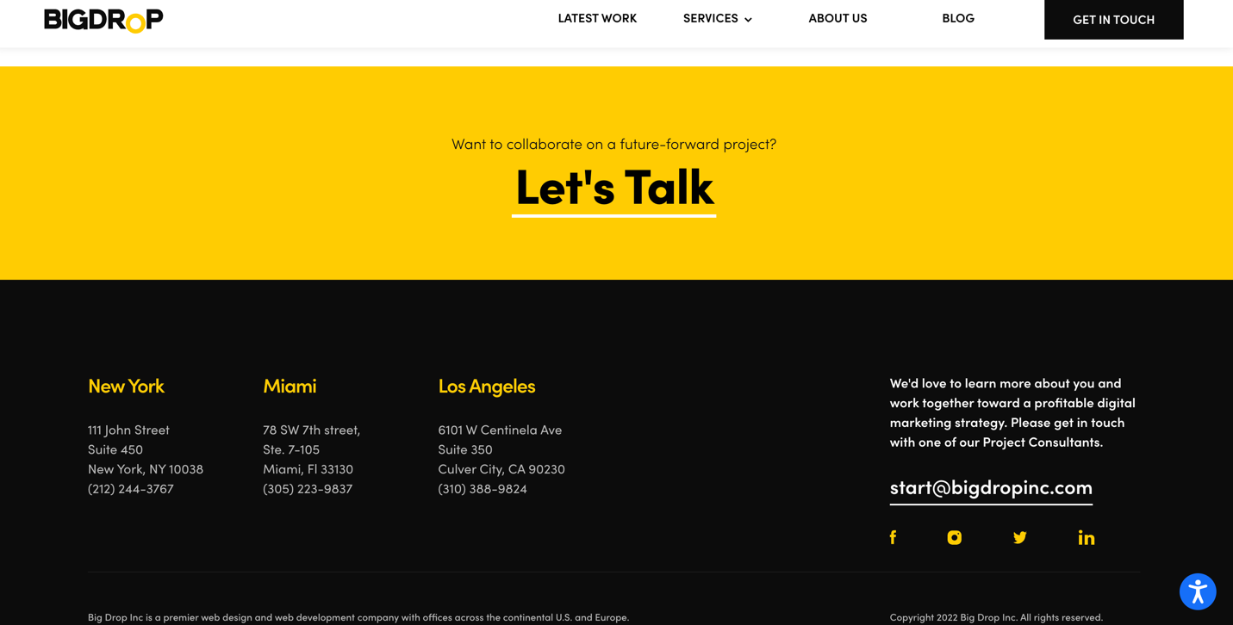

Pour le MENU on aura:

**Latest work- Services – About us – News**

**>> Service**

**EMC -RF - Energy Efficiency- support - Equipment and technologies**

**Latest work**

Ici on fera figurer juste des certificates (image) de 8 pays que je te ferais parvenir.

>>>>>> En dessous mettre la page de let’s talk encore>

Le texte:

|  |  |
| --- | --- |
| Want to approve your equipment and access the global market?  **Let’s Talk** | We collaborate with worldwide laboratories to provide Type Approval certifications and consultancy.  Let’s connect. |

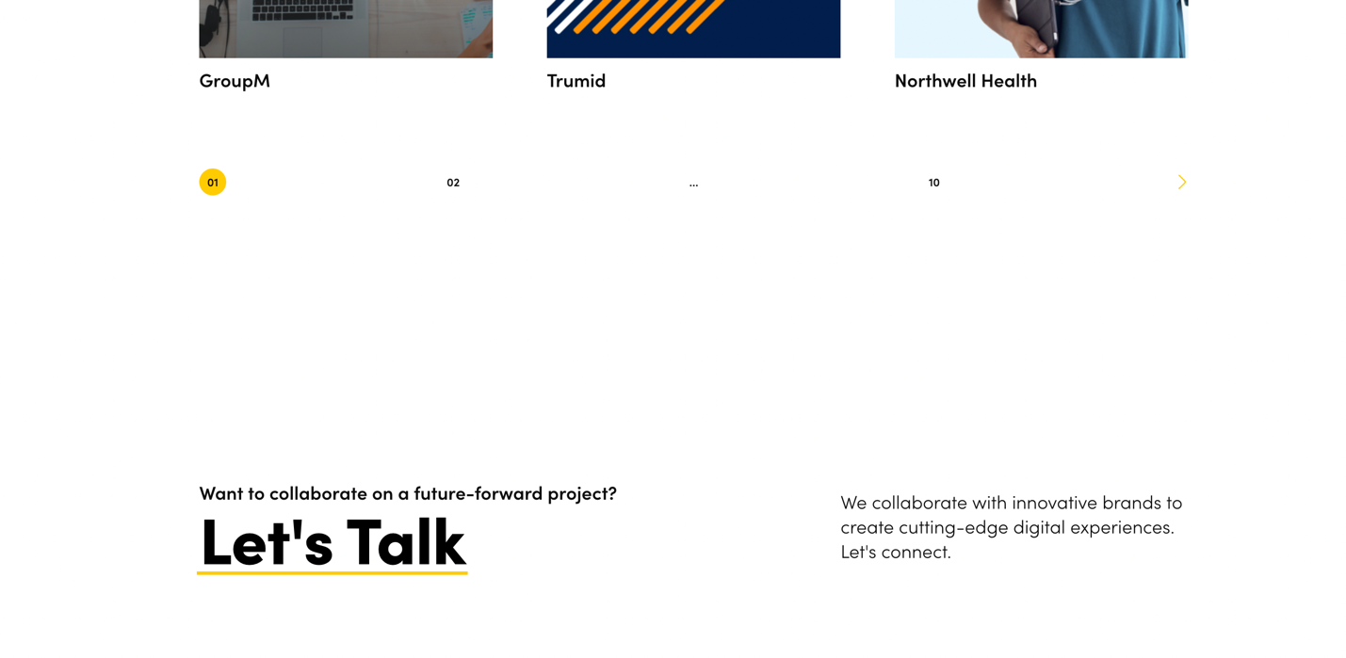

**Services**

**Services**

* **EMC**

**TEXTE:**

ElectroMagnetic Compatibility (EMC) is a characteristic of electrical and electronic equipment that permits it to operate as intended in the presence of other electrical and electronic equipment, and not to adversely interfere with that other equipment. All such equipment emits electrical energy, and some of that emitted energy may interact and interfere with other equipment.

Countries mandate specific test laboratories perform testing within their jurisdiction prior to products entering their market.

We offer you a complete and detailed review for your product and provide consultancy on how you can comply with the appropriate EMC regulatory requirements for your markets.

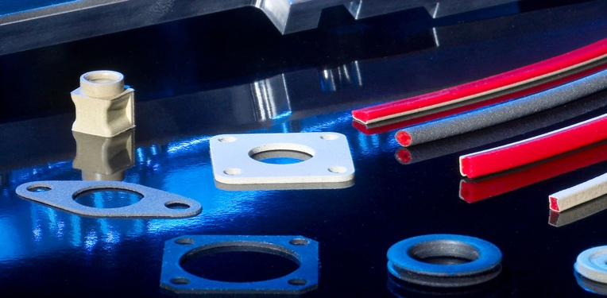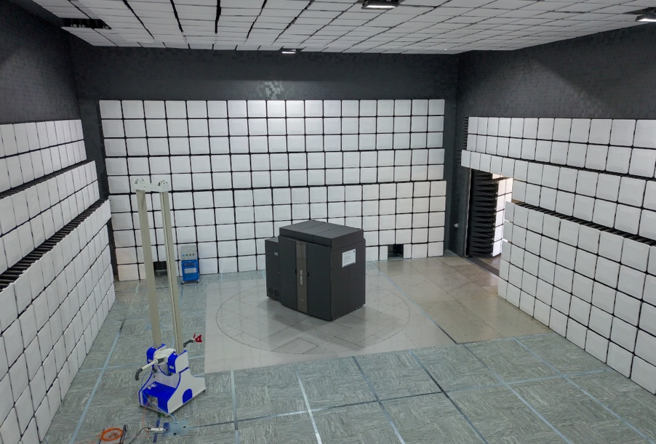

>>>>>> En dessous mettre la page de let’s talk encore>

Le texte:

|  |  |
| --- | --- |
| Want to approve your equipment and access the global market?  **Let’s Talk** | We collaborate with worldwide laboratories to provide Type Approval certifications and consultancy.  Let’s connect. |



* **RF**

**TEXTE**

**The use of radio technologies such as Bluetooth, Wi-Fi, radar, ultra-wideband and wireless power results in different test scenarios, which are necessary for the certification of a device and thus for its market launch.**

Countries mandate specific test laboratories perform testing within their jurisdiction prior to products entering their market.

We offer you a complete and detailed review for your product and provide consultancy on how you can comply with the appropriate EMC regulatory requirements for your markets.

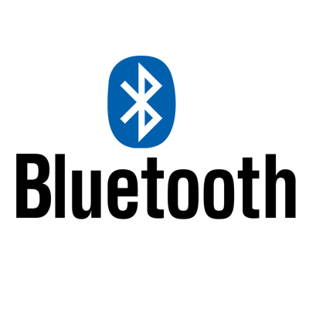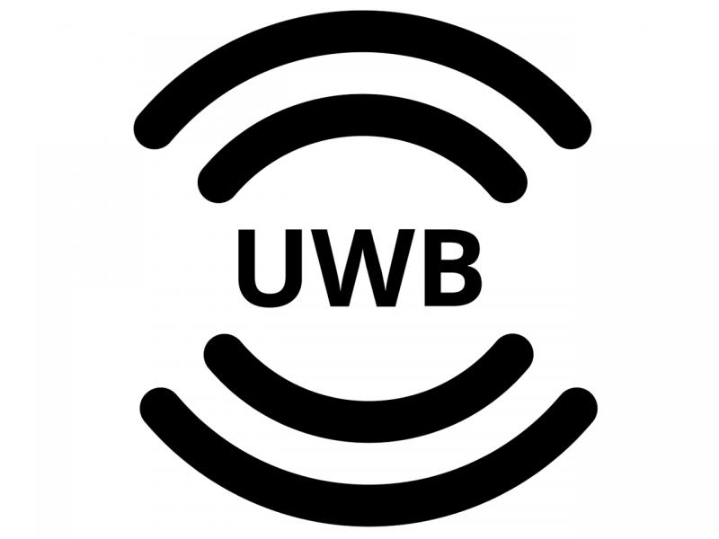



>>>>>> En dessous mettre la page de let’s talk encore>

Le texte:

|  |  |
| --- | --- |
| Want to approve your equipment and access the global market?  **Let’s Talk** | We collaborate with worldwide laboratories to provide Type Approval certifications and consultancy.  Let’s connect. |



* **Energy Efficiency**

**TEXTE:**

One way we can reduce the impact on climate change – and at the same time reduce operational costs – is by improving the energy efficiency of ICT products and services.

As more countries around the world become concerned about energy use and the growth of their high-tech sector the number of countries that now require or at least suggest you obtain some type of energy efficient certification is growing. In many countries we can utilize your existing test reports, but some countries will require samples be sent for in country testing at their specified labs.

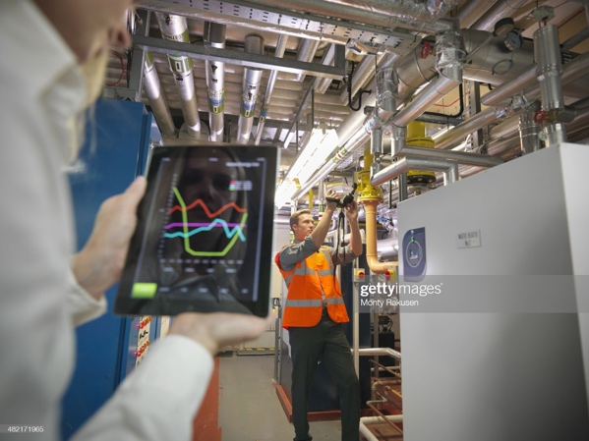



>>>>>> En dessous mettre la page de let’s talk encore>

Le texte:

|  |  |
| --- | --- |
| Want to approve your equipment and access the global market?  **Let’s Talk** | We collaborate with worldwide laboratories to provide Type Approval certifications and consultancy.  Let’s connect. |



* **Support**

## TECHNICAL SUPPORT

**before doing anything, our technical team will assist you to meet regulations that are always changing. It is our job to help you understand the requirements (allowed frequency band and power limits of equipment) to avoid any rejection.**

## Full Handling

Customer-oriented and fully functional regulatory and approvals database regarding to our dynamic and close relationships with in-country local agencies such as local tests laboratories, approval bodies, authorities, and local engineers among others, helping us to speed up the certification process, different products, and countries, including national requirements, policies, and technical regulations.

* **Adapted solutions** – Based on research of regulatory requirements, certification requisites and schemes for your product within your target country lists.
* **Interface with all regulators** – Interface with governmental organizations and certification bodies on behalf of clients lacking local representation. WAC Services often works with manufacturers where their products may not fit into the defined technical regulations.  We take the concerns to the regulatory body and explain the case for approval based on the lack of standards.  Our amazing relationships with the key regulators allow us the ability to discuss problems and help get the outcomes the manufacturer is looking for.
* **Testing matter** – WAC Services coordinates all product testing for a single or family of products in accordance with required test standards for each country that requires testing within their country
* **Getting competitive edge**– WAC Services expertise and knowledge, we can provide research to support the best decision-making process for our clients.

>>>>>> En dessous mettre la page de let’s talk encore>

Le texte:

|  |  |
| --- | --- |
| Want to approve your equipment and access the global market?  **Let’s Talk** | We collaborate with worldwide laboratories to provide Type Approval certifications and consultancy.  Let’s connect. |



* **Equipment and technologies**

|  |  |
| --- | --- |
| **Devices** | **Technologies** |
| **Access Points**  **Audio Video**  **Digital Cameras**  **Car Audio / Radio**  **Components (Radio Modules)**  **Computer Accessories: Keyboards, Mice, Dongles**  **Firewalls**  **Gaming Consoles**  **Printers / Fax Machines**  **Remote Controls**  **Routers**  **Smart Phones**  **Smart Watches**  **Switches**  **Tablets**  **Alarm / Security Systems**  **GPS Receivers**  **Sensors, RFID Readers**  **Key FOBs, Entry Systems**  **Laptops, Notebooks**  **Modems**  **Monitoring Equipment: Temperature, Pressure, Flow Level** | **Analogue (RJ-11, Fax) & Digital**  **Bluetooth, BLE**  **Cellular: GSM/CDMA, 3G, LTE**  **Ethernet Only**  **ISDN, E1, T1, Telecom**  **MICS, MEDS**  **NFC, RFID**  **Radar: 24 GHz, 76-77 GHz, etc.**  **Satellite: GPS, GLONASS, Galileo, Compass, SBAS**  **SRD/LPD (433.92 MHz, etc)**  **WiFi 802.11a/b/g/n/ac/ad/p**  **Wireless Charging (Qi, A4WP, etc.)**  **VoIP**  **ZIGBEE, Wireless HART** |

>>>>>> En dessous mettre la page de let’s talk encore>

Le texte:

|  |  |
| --- | --- |
| Want to approve your equipment and access the global market?  **Let’s Talk** | We collaborate with worldwide laboratories to provide Type Approval certifications and consultancy.  Let’s connect. |



**About us**

A propos de nous…

Le texte:

|  |
| --- |
| **ABOUT US**  **WAC Services** is a global compliance consulting, services provider company focusing in assisting manufacturers, consultants, and laboratory all around the world to meet international regulations by achieving global market access.  **Globally recognized**   * An internationally recognized, and respected player with team experience   **Technical approval expertise**   * Competent team of dedicated experts with many years of technical approval expertise   **Worldwide network**   * We offer a global network of long-standing partnerships and a bilingual staff, helping customers to get their products ready for business virtually anywhere in the world   **Regulatory and approvals database:**  Customer-oriented and fully functional regulatory and approvals database regarding to our dynamic and close relationships with in-country local agencies such as local tests laboratories, approval bodies, authorities and local engineers among others, helping us to speed up the certification process, different products and countries, including national requirements, policies and technical regulations.   * **Adapted solutions** – Based on research of regulatory requirements, certification requisites and schemes for your product within your target country lists. * **Interface with all regulators** – Interface with governmental organizations and certification bodies on behalf of clients lacking local representation. WAC Services often works with manufacturers where their products may not fit into the defined technical regulations.  We take the concerns to the regulatory body and explain the case for approval based on the lack of standards.  Our amazing relationships with the key regulators allow us the ability to discuss problems and help get the outcomes the manufacturer is looking for. * **Testing matter** – WAC Services coordinates all product testing for a single or family of products in accordance with required test standards for each country that requires testing within their country * **Getting competitive edge**– WAC Services expertise and knowledge, we can provide research to support the best decision-making process for our clients. |

PS; propose une image stp bro juste en dessous comme sur lexample ci dessous.

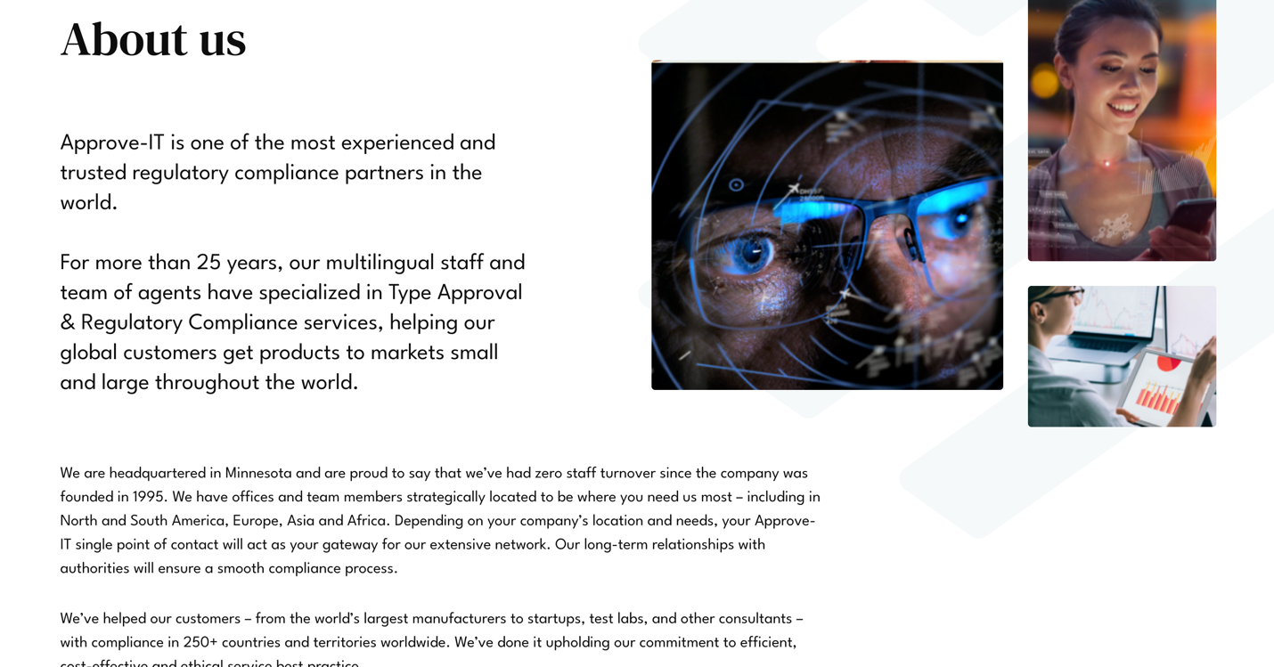

>>>>> en dessous mettre ca

Le texte:

|  |  |
| --- | --- |
| **What we do?**  There are over 35,000 consultants in the world., but there’s only one Wac-Services.  We pride ourselves on delivering, complete approval experiences that make an impact in manufacturers's process to access the global market. We’ve proudly partnered with Manufacturers, Accreditation Bodies, Laboratories, and worldwide Vendors, technologies.  **What We Believe:**  We believe that creating memorable experiences are the best way to connect with our consumers. | **Services**   * **EMC** * **RF** * **Electrical safety** * **Support**   **Latest work(bouton)**  **Get in touch (bouton)** |

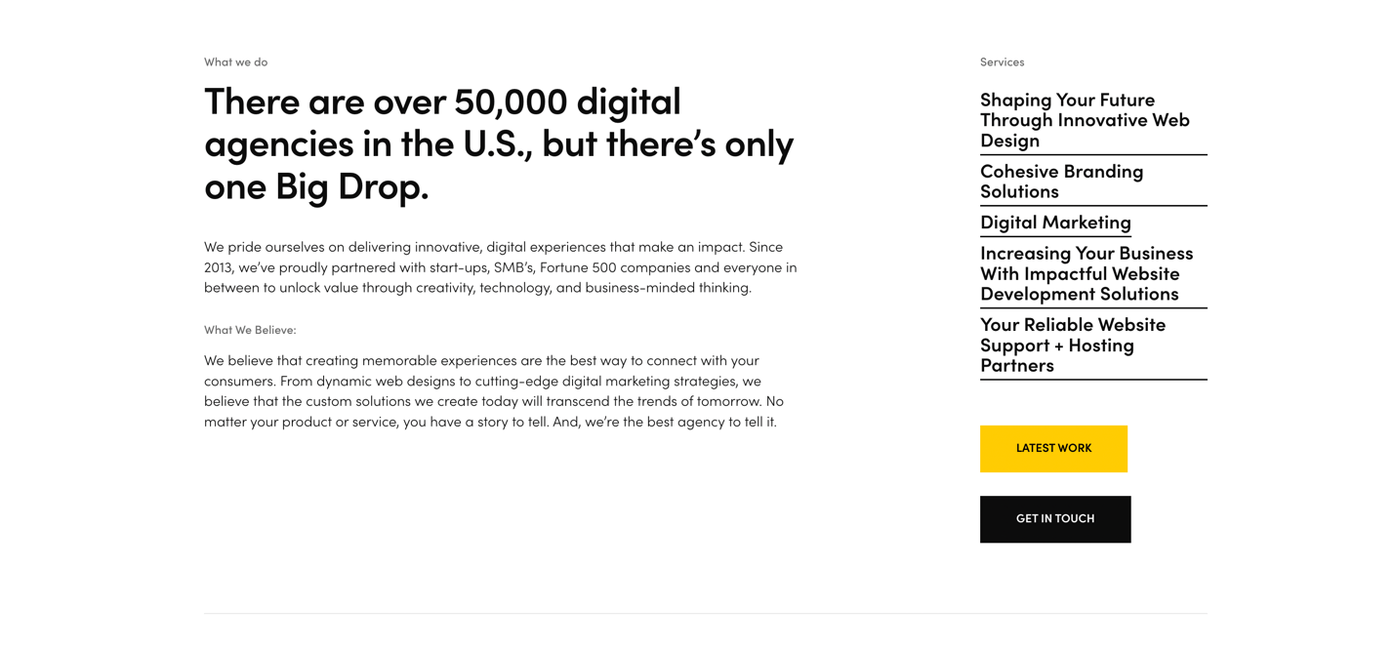

**News**

Les news de l’agence un peu comme on avait deja.

Rendre possible le filtre par date/ pays /

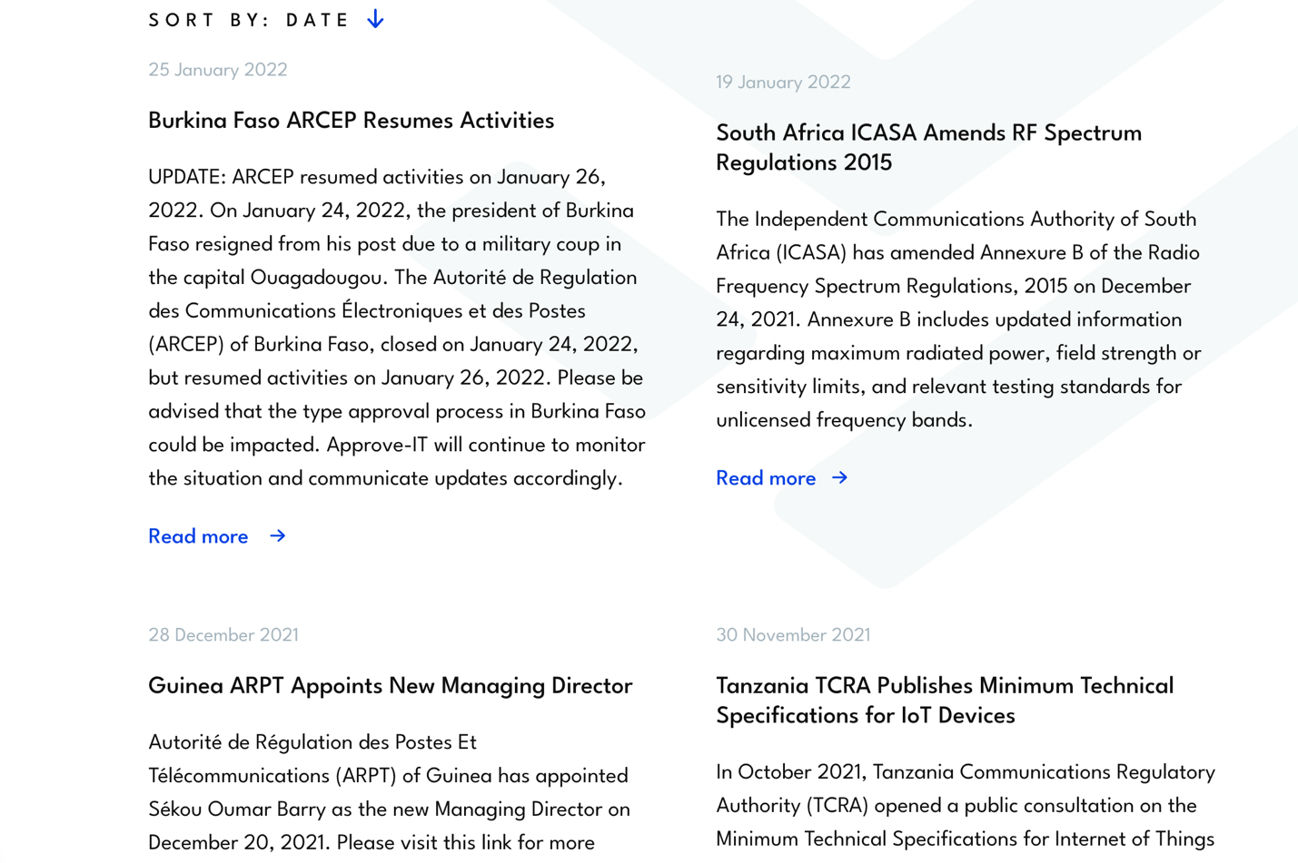

Tout s’affiche a la base comme ca mais quand on clique dessus o a l’info comme ci-dessous>

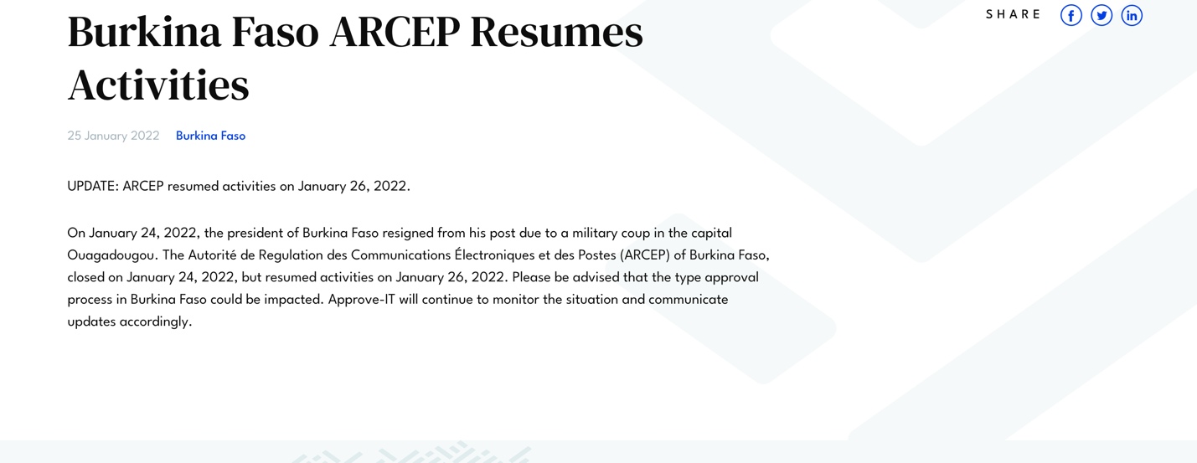

>>>> En dessous on aura le map qui pourra nous donner une vue sur les pays couvert.

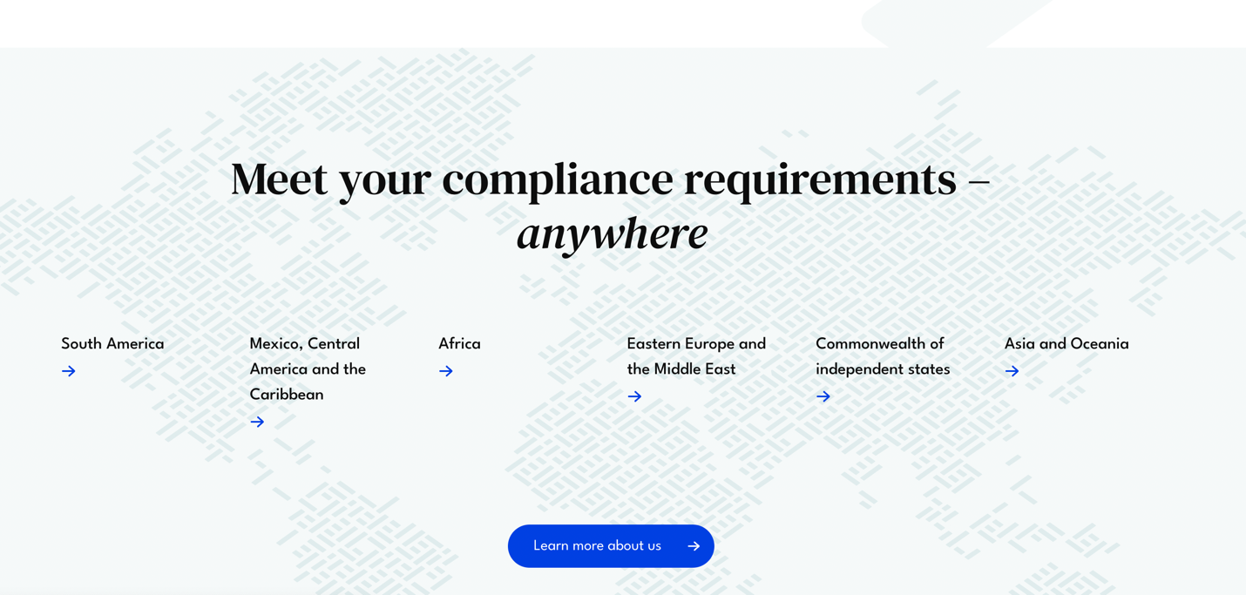

**Lest talk**

**Texte:**

|  |  |
| --- | --- |
| Want to approve your equipment and access the global market? Tell us about your needs, we’d love to collaborate with you.  **info@wac-services.com** | Garder tout sauf le dernier champs. rendre tous les champs obligatoires. |

